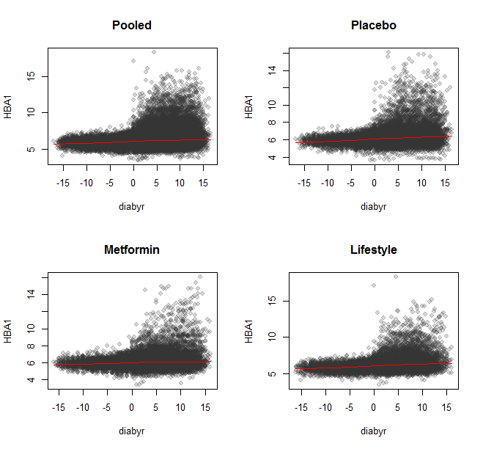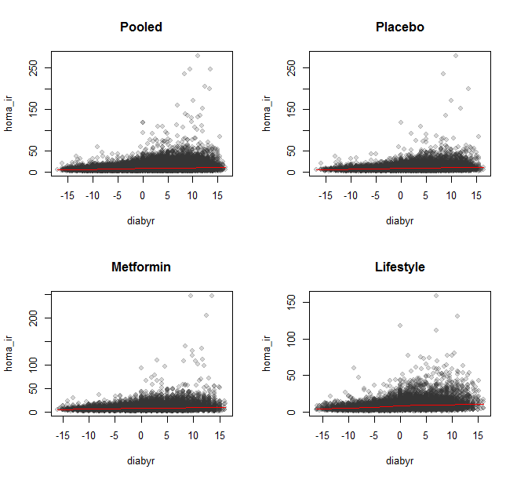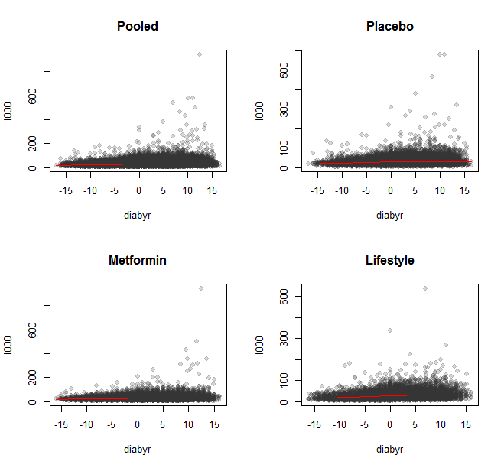

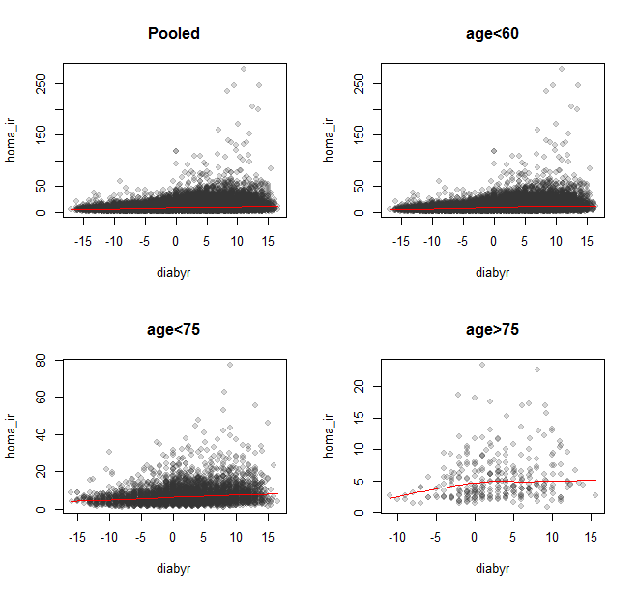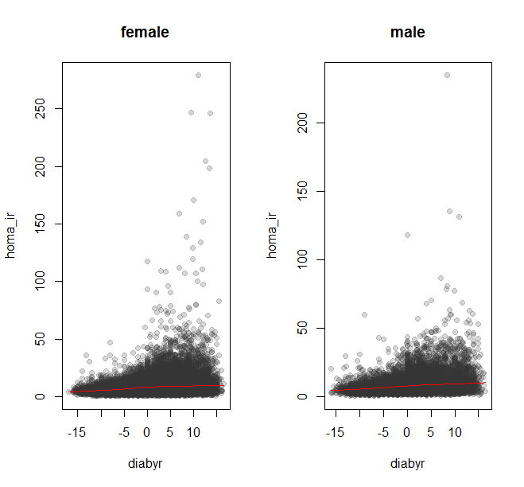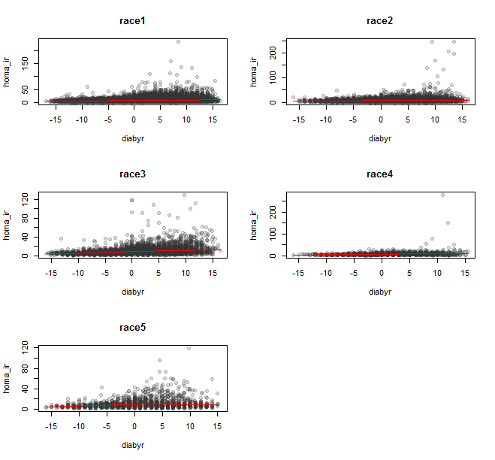

NLME:

Sample:

Diabyr<=0 & ASSIGN = ‘Metformin” & have at least 6 measurements of outcome.

Model:

Homa_ir ~ spline(-diabyr, degree=3, tau=5)+ra1_i

Speed~ agerand : time_i= exp(ra3_i+agerand*beta)*time – ra2_i

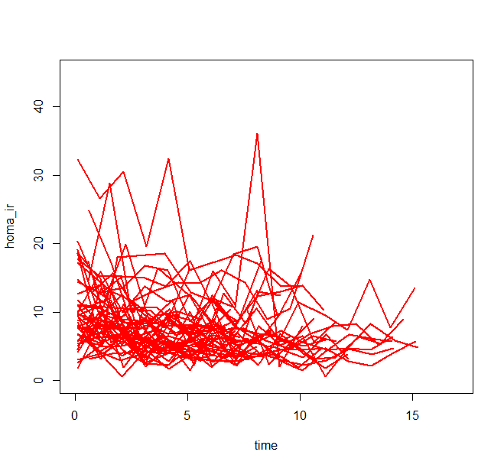

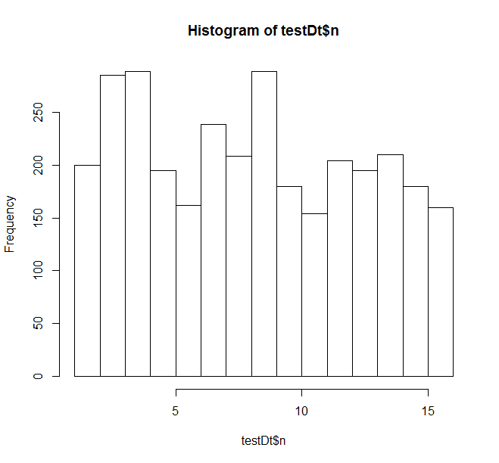

NLME:

Sample:

Diabyr<=0 & ASSIGN = ‘Metformin” & have at least 6 measurements of outcome.

Model:

Homa_ir ~ spline(-diabyr, degree=3, tau=5)+ra1_i

Speed~ agerand : time_i= exp(ra3_i+agerand*beta)*time – ra2_i

Nonlinear mixed-effects model fit by maximum likelihood

Model: homa_ir ~ d3k1_model(time = time, beta0, beta1, beta2, beta3, beta4, ra1_i, ra2_i, ra3_i, tau1 = 5, covar1 = agerand, cov.coef1)

Data: testDt

AIC BIC logLik

11931.72 12005.65 -5952.861

Random effects:

Formula: list(ra1_i ~ 1, ra2_i ~ 1, ra3_i ~ 1)

Level: patid

Structure: General positive-definite, Log-Cholesky parametrization

StdDev Corr

ra1_i 3.277485e+00 ra1_i ra2_i

ra2_i 1.094704e-04 0.015

ra3_i 4.613873e-05 -0.002 0.022

Residual 3.303476e+00

Fixed effects: beta0 + beta1 + beta2 + beta3 + beta4 + cov.coef1 ~ 1

Value Std.Error DF t-value p-value

beta0 11.270861 0.3526223 1954 31.96298 0.0000

beta1 -2.284363 0.3334310 1954 -6.85108 0.0000

beta2 0.460164 0.0959635 1954 4.79520 0.0000

beta3 -0.032381 0.0078507 1954 -4.12461 0.0000

beta4 0.034588 0.0098235 1954 3.52094 0.0004

cov.coef1 0.005219 0.0039129 1954 1.33385 0.1824

Correlation:

beta0 beta1 beta2 beta3 beta4

beta1 -0.385

beta2 0.282 -0.982

beta3 -0.219 0.960 -0.994

beta4 0.142 -0.925 0.973 -0.991

cov.coef1 0.232 0.535 -0.591 0.645 -0.729

Standardized Within-Group Residuals:

Min Q1 Med Q3 Max

-3.78870339 -0.51013418 -0.07921096 0.37356495 8.59753167

Number of Observations: 2179

Number of Groups: 220

| **ra1_i** | | **ra2_i** | | **ra3_i** | | **patid** | |
| --- | --- | --- | --- | --- | --- | --- | --- |
|  |  | |  | |  | |  |
| **012001** | 4.583077969 | | 1.945544e-06 | | -1.566887e-07 | | 012001 |
| **012004** | -3.055968165 | | -1.303056e-06 | | 1.053808e-07 | | 012004 |
| **012052** | -3.570613178 | | -1.517309e-06 | | 1.218841e-07 | | 012052 |
| **012053** | 0.338007358 | | 1.445147e-07 | | -1.434613e-08 | | 012053 |
| **012063** | -3.226294322 | | -1.379553e-06 | | 1.097476e-07 | | 012063 |
| **012080** | 0.403792216 | | 1.794701e-07 | | -1.368187e-08 | | 012080 |
| **012084** | 4.130869635 | | 1.762670e-06 | | -1.411675e-07 | | 012084 |
| **012085** | 0.166887495 | | 5.941066e-08 | | -5.789819e-09 | | 012085 |
| **012105** | -3.298882511 | | -1.400412e-06 | | 1.131151e-07 | | 012105 |
| **012132** | -3.375459584 | | -1.426623e-06 | | 1.171344e-07 | | 012132 |
| **012149** | 3.598361625 | | 1.536875e-06 | | -1.180428e-07 | | 012149 |
| **012163** | 1.580378290 | | 6.602320e-07 | | -4.388105e-08 | | 012163 |
| **022010** | 0.032899045 | | 4.165579e-08 | | -2.727313e-09 | | 022010 |
| **022018** | -2.080065533 | | -8.882920e-07 | | 7.290131e-08 | | 022018 |
| **022031** | -2.942148735 | | -1.253119e-06 | | 1.015505e-07 | | 022031 |
| **022054** | -3.730306285 | | -1.591371e-06 | | 1.293035e-07 | | 022054 |
| **022055** | 7.405291298 | | 3.131114e-06 | | -2.483522e-07 | | 022055 |
| **022066** | -0.372627059 | | -1.642692e-07 | | -1.049135e-07 | | 022066 |
| **022120** | -2.683487018 | | -1.144729e-06 | | 9.025852e-08 | | 022120 |
| **022141** | -1.606431114 | | -6.834345e-07 | | 5.493893e-08 | | 022141 |
| **032005** | -2.755735101 | | -1.178169e-06 | | 9.274873e-08 | | 032005 |
| **032016** | -3.515306102 | | -1.496323e-06 | | 1.207558e-07 | | 032016 |

